7/4/2025

Klil Harburger, Rotem Azriel, Idan Schraiber, Yuval Antman

Introduction to data science

[Link to our Git Repository](https://github.com/yuvalantman/covid_crime_research)

Balancing the Curve

Modelling the Impact of Lockdown Policies on Domestic Violence and COVID-19 Outcomes

**1.Introduction**

The COVID-19 pandemic forced governments worldwide to implement strict lockdowns, which significantly reduced virus transmission and saved lives in many countries (Acemoglu et al., 2023). However, growing evidence shows that lockdowns also had unintended social consequences - particularly an increase in domestic violence (DV). These effects were not equally distributed and appear to grow stronger the longer lockdowns continued.

Kourti et al. (2023) reviewed 18 studies across multiple regions and found that 14 of them (78%) reported an increase in DV during lockdown periods. Sacco et al. (2020) noted that the isolation and stress caused by home confinement created "ideal conditions" for abuse, especially when victims had no safe access to external help. Several studies found extended lockdowns may sharply increase DV, whether through formal reports (Peterman et al., 2020) or indirect signals like DV-related search spikes (Anderberg et al., 2020).

At the same time, lockdowns did prevent deaths, especially in the early stages of the pandemic. But as Acemoglu et al. (2023) argue, the health benefit of longer lockdowns starts to plateau after a certain point, particularly when combined with other policies like income support and workplace closures. Evans et al. (2020) and Sharma & Borah (2020) emphasize that such social protections can moderate the impact of lockdowns on DV by reducing financial strain and offering some relief to families under pressure.

This background raises a central question: **Is it possible to identify an optimal lockdown length for each country - one that reduces COVID-19 deaths effectively but avoids triggering a significant rise in domestic violence?**

While our analysis does not claim to prove causality, we base our approach on robust findings from prior research and explore this question using data from over 20 countries. Our work contributes to a deeper understanding of the trade-offs in public health policy, particularly when the private sphere becomes one of the main sites of harm.

**2. Data Overview**

Our analysis uses monthly data from October 2019 to August 2020, covering 20+ countries depending on feature availability. Datasets were compiled mainly from the Oxford COVID-19 Government Response Tracker (OxCGRT, via Our World in Data) and UNODC's domestic violence reports. The key features used include:

* **Domestic violence indicators**: raw monthly counts, per-million rates, and changes from pre-COVID baselines.
* **COVID-19 deaths**: monthly death rates per million, including lagged death values and percent changes from the average of a country during the months covered.
* **Policy features**: lockdown length and severity, workplace closures and income support - aggregated into monthly scores from daily OxCGRT values (0-3 per day).
* **Engineered features**: continuity of lockdowns, lagged and scaled variables, and “lockdown power,” combining intensity and duration.

All data was aligned at the country-month level, and features were designed to capture both the direct effects of the pandemic and the policy context that may have shaped domestic violence trends.

**3. Methods & Results**

Given the limited and non-experimental nature of our data, our analysis is entirely exploratory. We do not attempt to prove causality but rather to identify meaningful patterns and trade-offs consistent with prior research. Our goal was to examine how different COVID-19 policy features-particularly lockdown length - related to changes in domestic violence (DV) reports and death rates across countries during the first wave of the pandemic. We approached this through three sequential stages of analysis.

Data Preparation and Feature Engineering:

We aligned monthly data from 20–24 countries (Oct 2019–Aug 2020) and engineered key features from daily OxCGRT policy indicators. These include monthly lockdown severity, income support, and workplace closures. We created variables like lockdown length, lagged DV and death changes, and “lockdown power” (a weighted index of duration and intensity). This allowed us to capture both immediate and cumulative policy effects at the country-month level without relying on simplistic binary indicators.

Stage 1 – Policy approach and Lockdown thresholds:

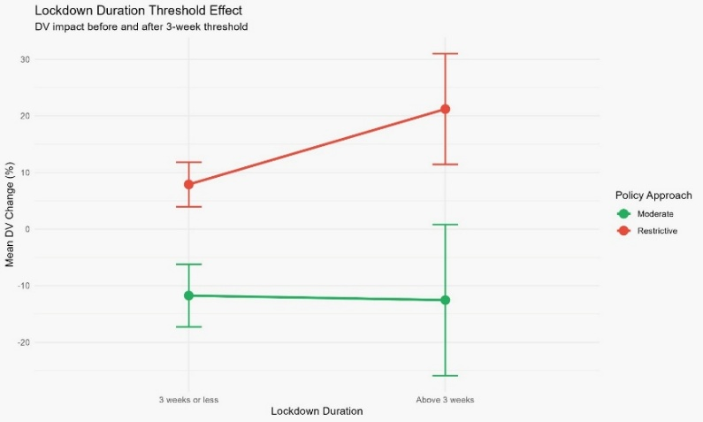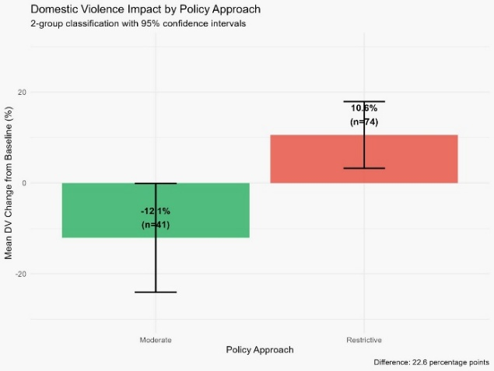We grouped countries by Restrictive vs. Moderate policy responses based on lockdown severity and economic support. DV rose by 10.6% in Restrictive countries (n = 74) and fell by 12.1% in Moderate ones (n = 41). Among Restrictive countries, DV rates climbed notably when lockdowns exceeded three weeks, while Moderate ones showed no such trend. Stepwise regression improved from adj. R² = 9.8% to 18.4% as policy design and interaction terms were added—highlighting both duration and support policy as important factors.

Stage 2 - Aftereffects of Lockdowns on Domestic Violence:

We analyzed 11 country-level lockdown waves with full data for both lockdown and 1–4 months after. For each, we compared average DV rates post-lockdown to during, producing an “aftereffect” score. Both scatter and boxplots revealed a clear upward trend, with lockdowns longer than ~54 days consistently followed by higher DV levels. This aligns with studies showing delayed DV surges post-confinement (e.g., Anderberg et al., 2020). While our sample is small, this pattern supports the idea that prolonged lockdowns may lead to cumulative social strain.

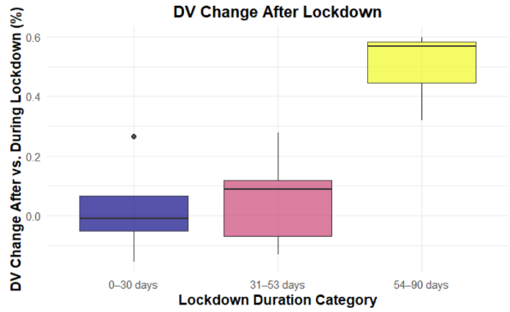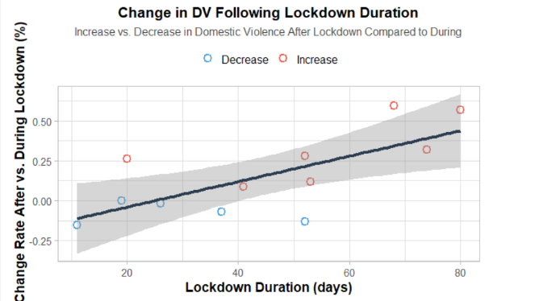

Stage 3 – Estimating optimal Lockdown length:

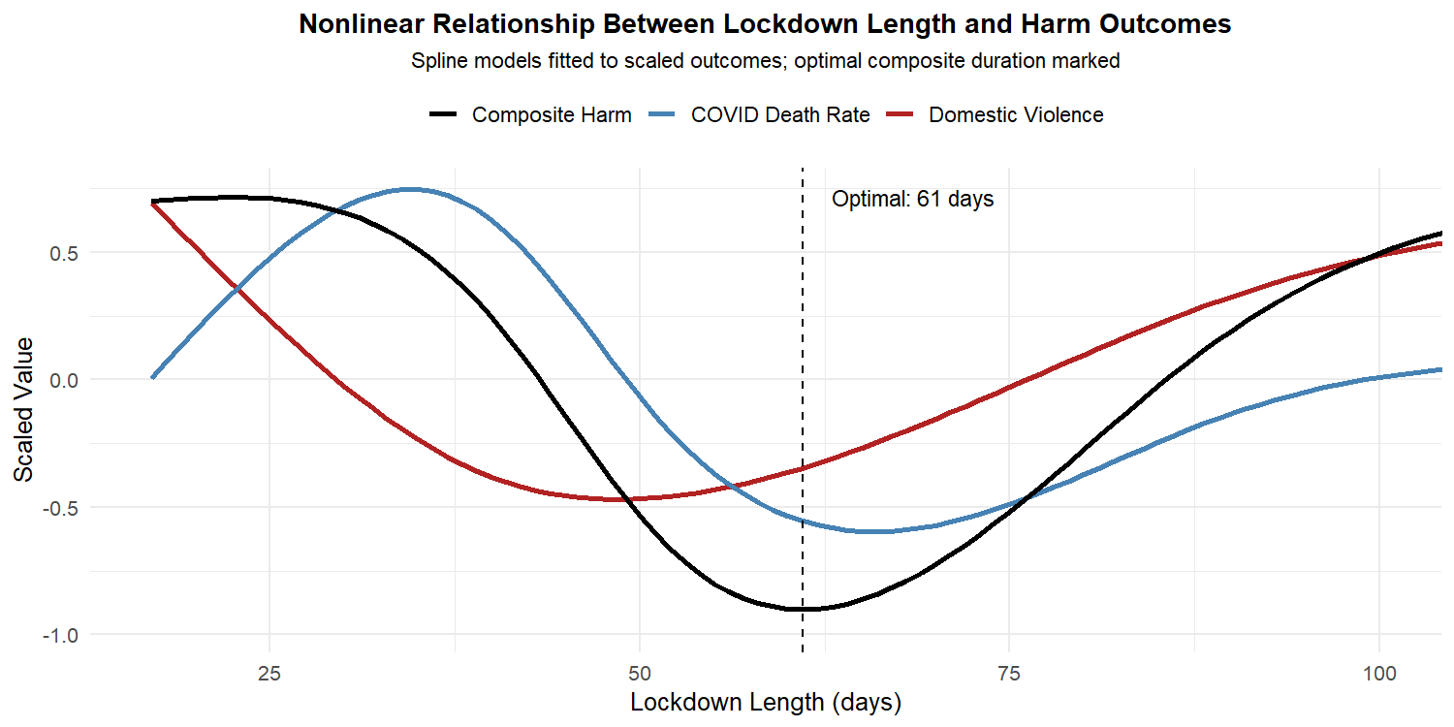We created a composite harm score combining scaled DV percent change and scaled COVID death percent change from the previous month. Using 35 post-April country-months, we modeled this outcome against lockdown length via a spline regression (df = 4). The model explained 27% of the variance (**Adjusted R² = 0.27**) and was statistically significant (**F(4,30) = 3.29, p = 0.024**), showing a U-shaped curve with a minimum at **61 days**—suggesting that extending lockdowns beyond two months may worsen combined health and social harms. A comparison model using death change from baseline yielded a similar curve (optimal day = 55) but weaker fit (Adj. R² = 0.13, p = 0.06). While exploratory, the result aligns with prior findings that long lockdowns can become counterproductive (Kourti et al., 2023; Acemoglu et al., 2023).

Top of Form

Bottom of Form

**4. Future work & Limitations:**

Our analysis is based on a small sample of countries with incomplete and uneven reporting. In many cases, domestic violence was likely underreported, especially during lockdowns, and some lockdowns continued beyond our dataset, limiting post-lockdown insights.

We used simplified indicators (death and DV rates per million) and focused only on reported cases. This may underestimate real harm, as shown in prior work using search data and helpline calls (e.g., Anderberg et al., 2020).

Future research could expand the dataset, include more countries and months, and integrate additional sources like Google Trends or survey data. With larger samples, stronger statistical models or causal frameworks could be applied to test these patterns more rigorously.

Our findings are exploratory—but they align with past studies and show how even small datasets can support informed thinking about policy trade-offs.